**Reinforcement Learning Coursework 4**

**WU Zhi 17040772** [**UCABWUA@UCL.AC.UK**](mailto:UCABWUA@UCL.AC.UK)

**Department of Computer Science**

**University College London**

# Assignment 1

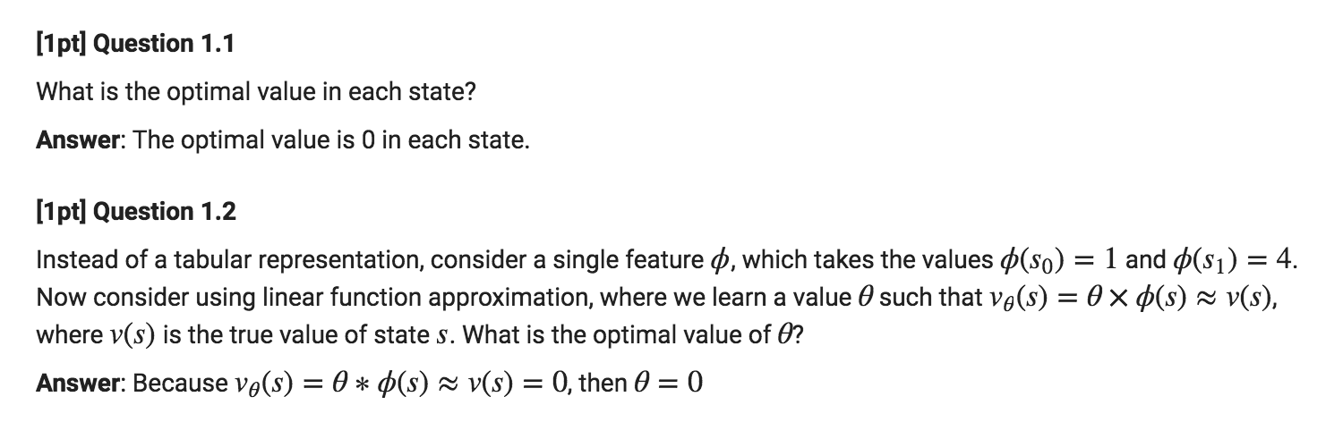

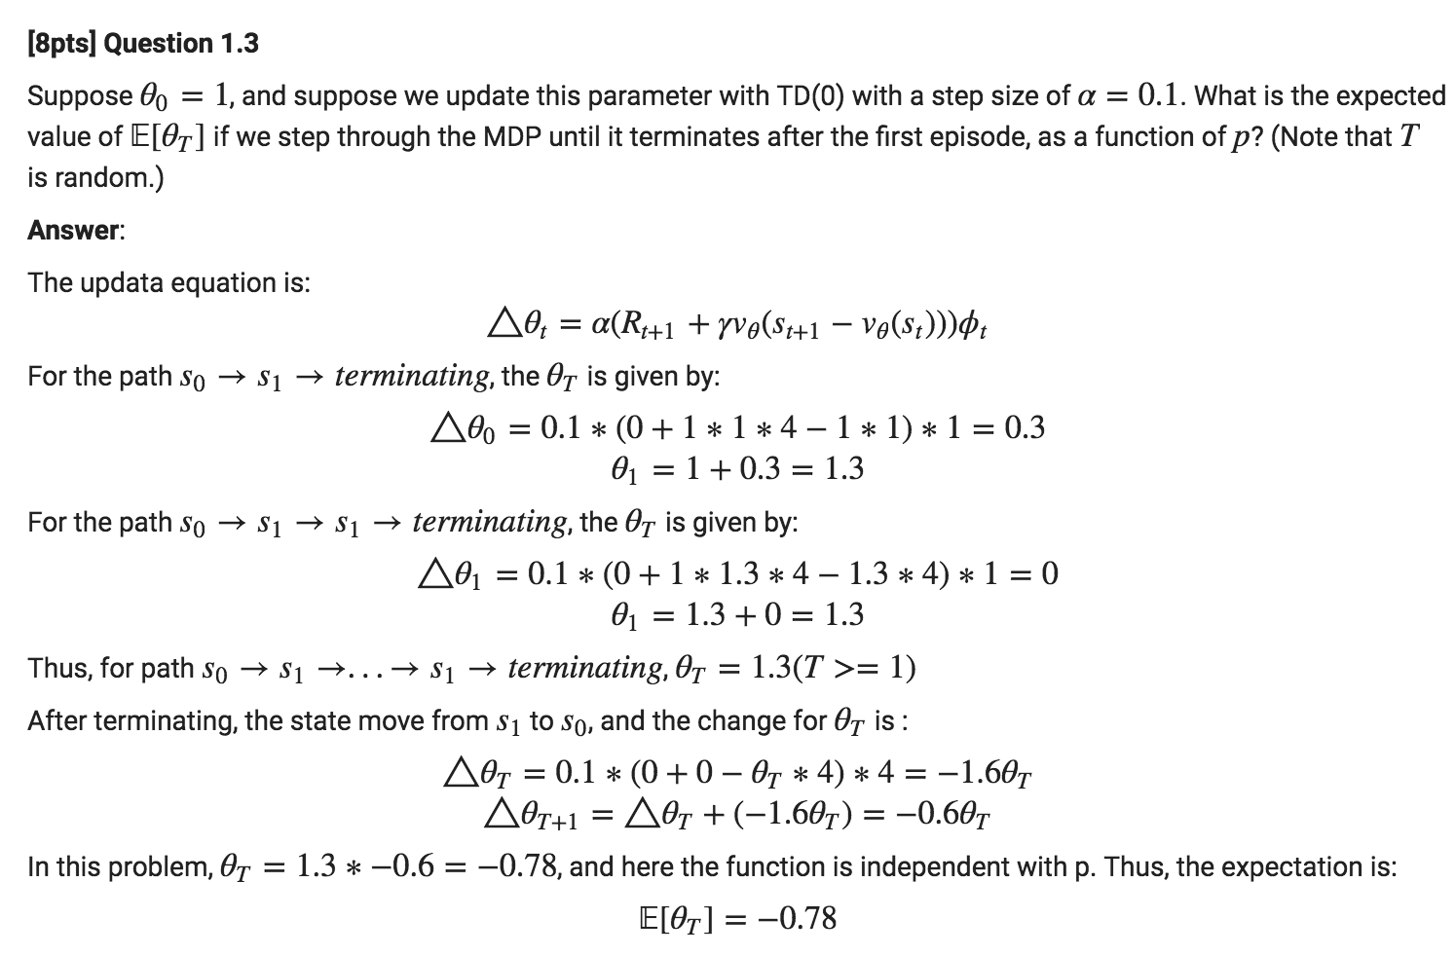

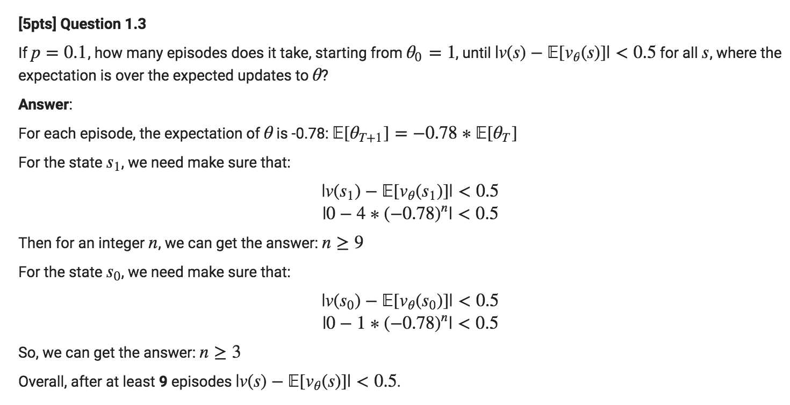

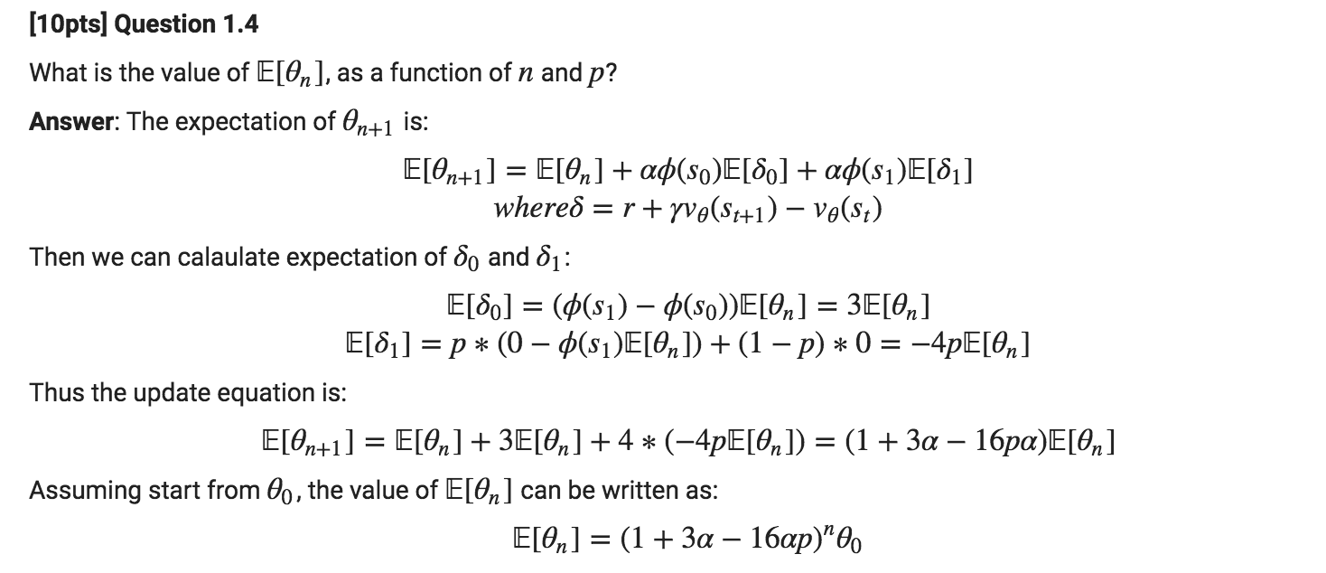

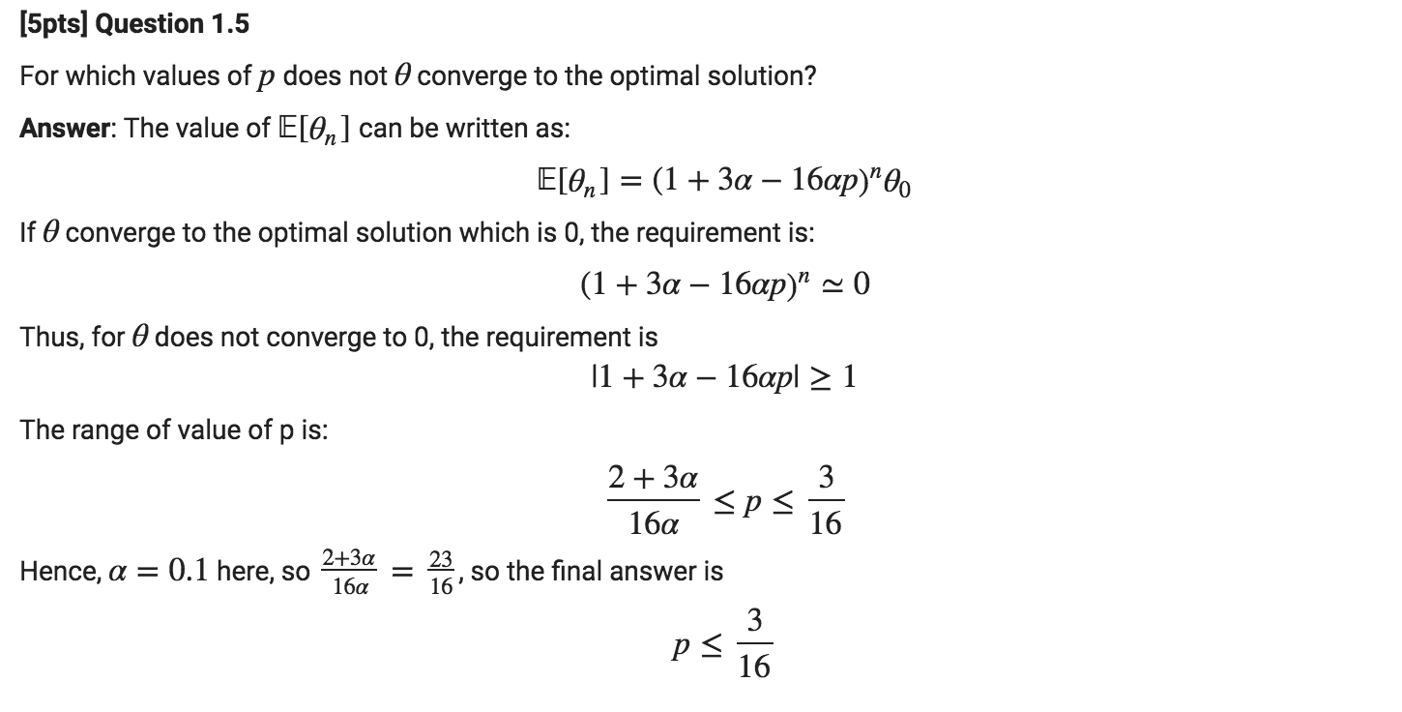

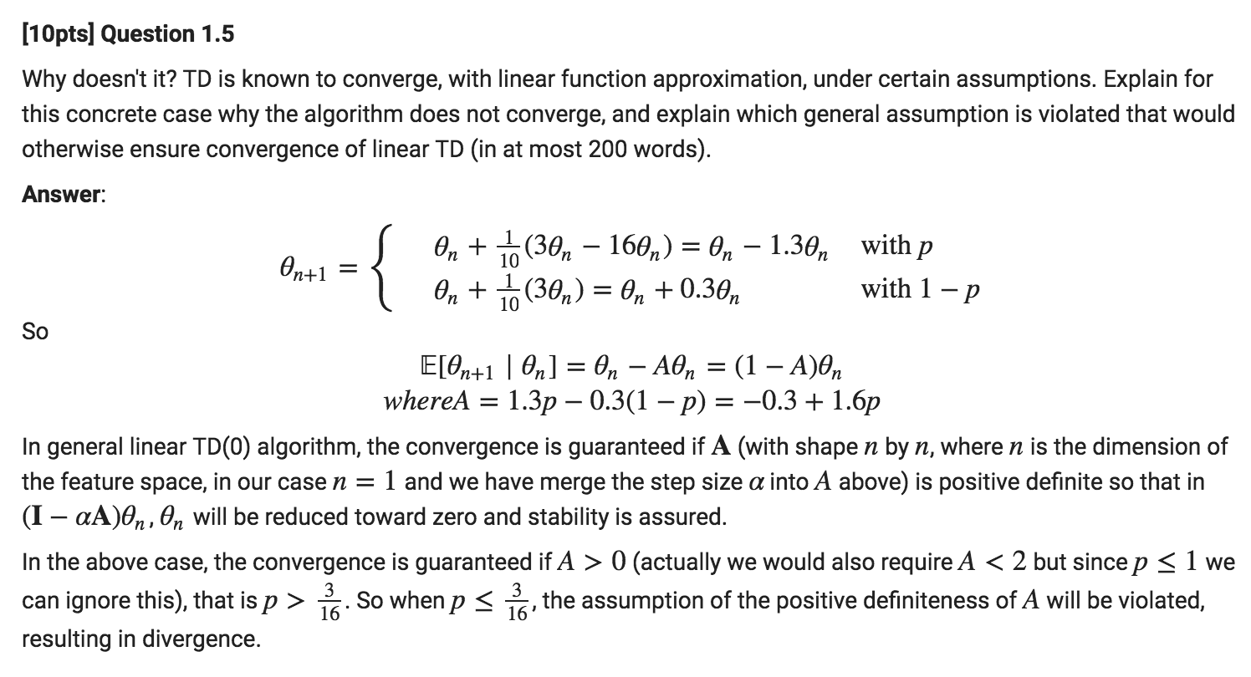

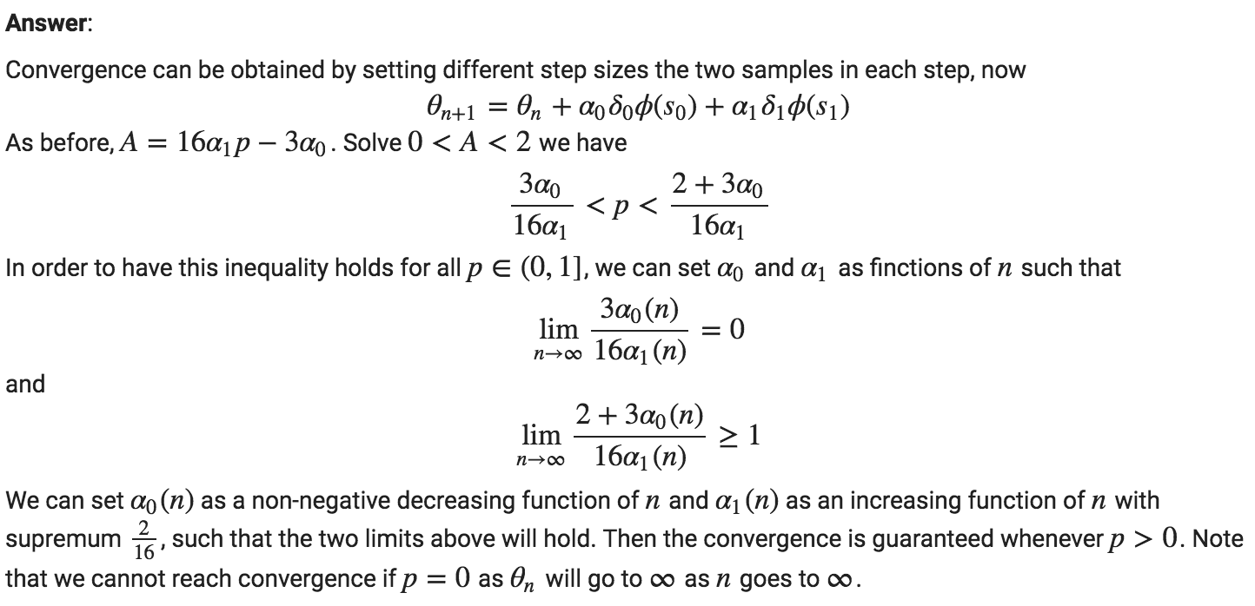

# Assignment 2

## Plots

### SARSA



### Vision size of 1



### Vision size of 2



## Questions

